**OS LAB 05**

Name: rabia Id: FA17-BECE-2001

TASK1:

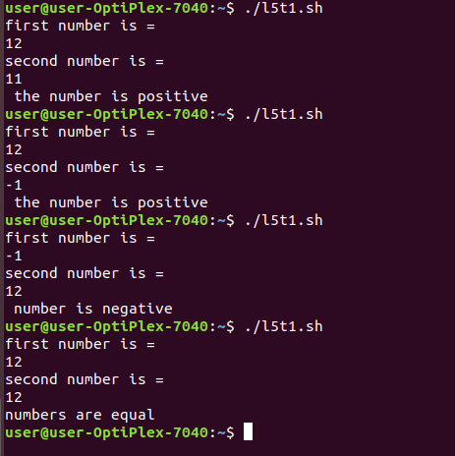

TASK2:

